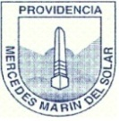
Colegio Mercedes Marín del Solar
Providencia
Delia Maulén
Worksheet 1 “school supplies”
Activity 1: Read or listen and color the school supplies
The book is Green | The crayon is yellow | The pencil is red
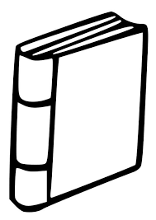 | 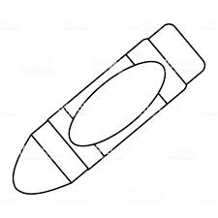 | 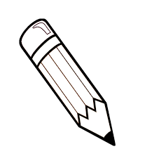
The glue is purple | The ruler is blue | The rubber is pink  The eraser is pink
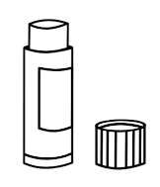 | 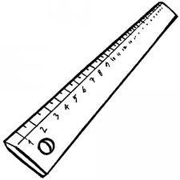 | 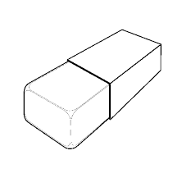
The school bag is Green and brown | The sharpener is orange | The pen is black
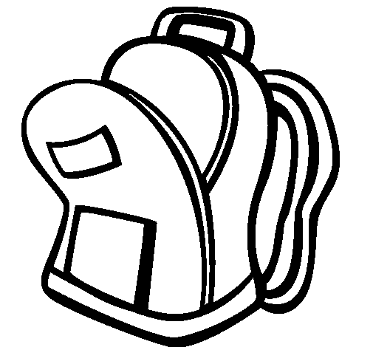 | 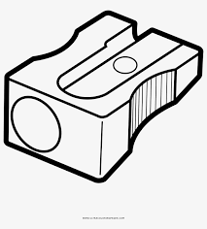 | 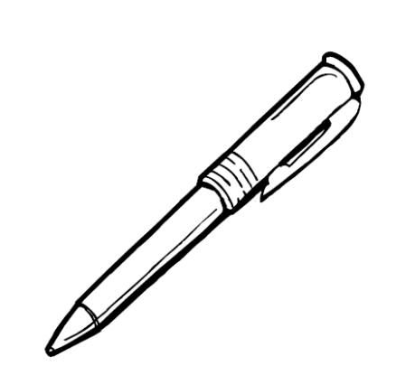

Activity 2: match the pictures and the words
Glue
Pencil
Rubber / Eraser

Book
Shapener
Ruler
School bag

