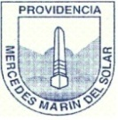
Colegio Mercedes Marín del Solar
Providencia
Delia Maulén
Worksheet 1 “Personal presentation and colors”

