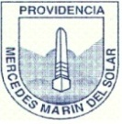
Colegio Mercedes Marín del Solar
Providencia
Delia Maulén
Worksheet 1 “ready for school”
Activity 1: Read, draw and color
The book is Green | The crayon is yellow | The pencil is red
The glue is purple | The ruler is blue | The rubber is pink  The eraser is pink
The school bag is Green and brown | The sharpener is orange | The pen is black

Activity 2: match the pictures and the words
Glue
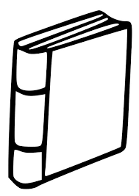
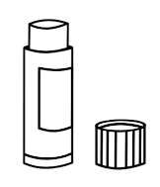
Pencil
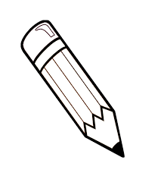
Rubber / Eraser

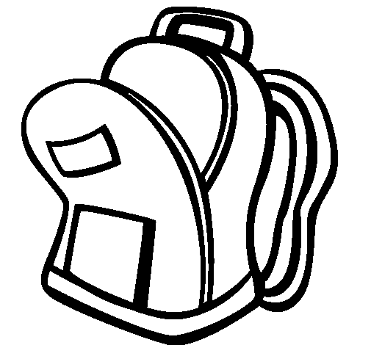
Book
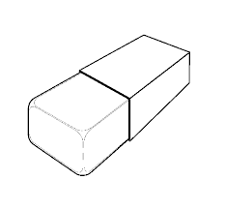
Shapener
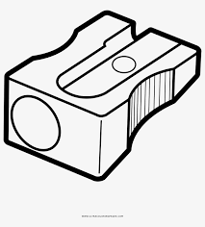
Ruler
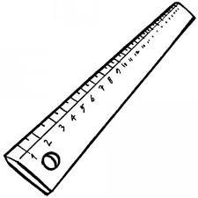
School bag

Activity 3: find the words of the school supplies in the wordsearch
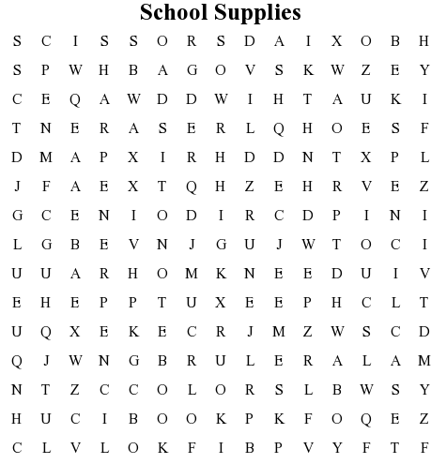
• colors
• eraser
• bag
• pen
• pencil
• glue
• scissors
• pencil case
• book
• ruler
• sharpener
• notebook

Activity 4: complete the words under the school supplies

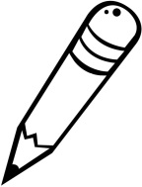 | 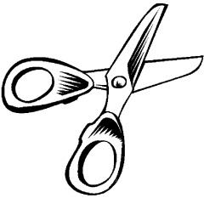 | 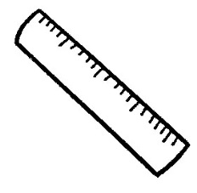 | 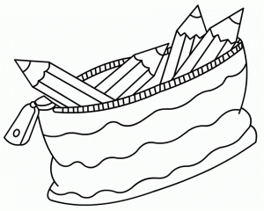
_ _ _ _ _ _ | _ _ _ _ _ _ _ _ | _ _ _ _ _ | _ _ _ _ _ _  _ _ _ _
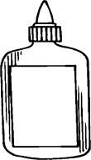 |  | 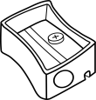 | 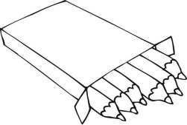
_ _ _ _ | _ _ _ _ _ _ | _ _ _ _ _ _ _ _ _ | _ _ _ _ _ _
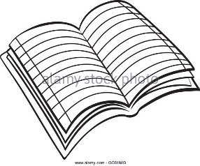 | 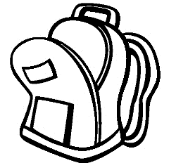 | 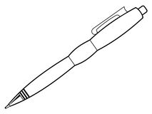 | 
                    

