COLEGIO MERCEDES MARÍN DEL SOLAR
UTP/ DEPARTAMENTO DE INGLÉS
PROFESOR (A) ARELI DONOSO N.

ENGLISH WORKSHEET
“DAILY ROUTINE”
5TH GRADE

NAME: ______________________ GRADE: __________ DATE: ________

IDEAL SCORE:24 YOUR SCORE: ____ LEVEL OF DIFFICULTY: 60%

USE OF ENGLISH

1. Write the Number of every action under the correct picture (6 points)

1. Have breakfast 7. Have a bath
2. Go Home 8. Get up
3. Read a book 9. Do homework
4. Have a shower 10. Watch T.V
5. Go to sleep 11. Get dressed
6. have lunch 12. Brush my teeth

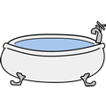
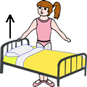

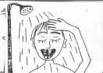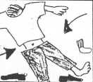

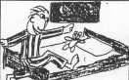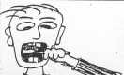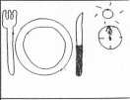

READING
Emma’s daily routine
Hello, my name is Emma and I am 10 years old. I live with my family in Viña del Mar. I get up at 7:30. Then I have a shower, get dressed, and comb my hair before breakfast. At 8:00 I have breakfast with my brother Tommy. I usually have a bowl of cereal with milk and a toast with marmalade. After breakfast I brush my teeth and go to school at 8: 20. Classes start at 8:45 and finish at 2:00. After classes I go home and have lunch at 2:30. I have a rest and do my homework at 4:00. After that I play with my brother and watch Television. At 7:00 I have a glass of milk and a sandwich. Finally I read my favourite book in the living room and I go to bed at 9:00.

1. Read the text about Emma’s daily routine and answer True or False ( 5 points)
1. ________ Emma lives in Chile.
2. ________ Emma combs her hair and then has a shower.
3. ________ Emma has a sandwich for breakfast.
4. ________ Emma has lunch at 2:30.
5. ________ Emma reads a book at 9:00.

2. Read the text again and order Emma’s daily routine (1 – 8) ( 8 points)
a. Emma has lunch _______________
b. Emma watches television ___________
c. Emma brushes her teeth ____________
d. Emma has a shower ________________
e. Emma does her homework ___________
f. Emma gets up ________________
g. Emma goes to school ________________
h. Emma goes to bed ________________

WRITING
4. Write 5 Daily routine activities you do during the day In the order you do them. (5 points)
1.____________________________________________________________________________
2. ____________________________________________________________________________
3. ____________________________________________________________________________
4. ____________________________________________________________________________
5. ____________________________________________________________________________

