Mark

Colegio Mercedes Marín del Solar
Providencia
Delia Maulén
Nivel: 6° básico
Web quest
Name: ____________________________________ grade: __________ date: _________

Total score: 14 points real score: ____________ achievement level: 60%
Step 2: 2 points
Step 3: 4 points
Step 4: 4 points
Step 5: 4 points

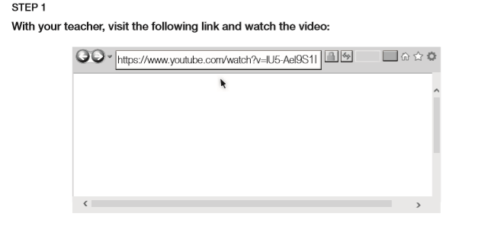

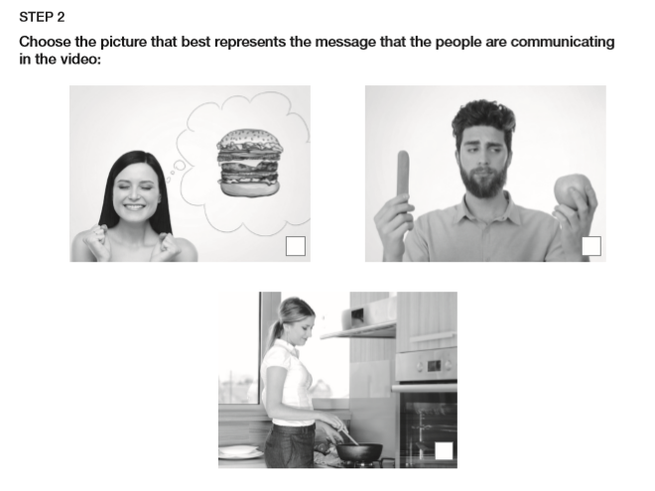
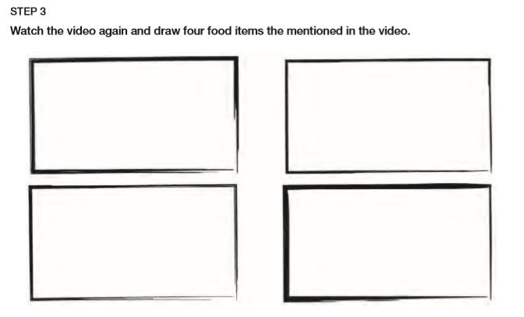
Step 5:
Give your opinión. Write one sentence for each expresión and add a food ítem. Draw it.
I LIKE | I HATE | I DON´T LIKE | I LOVE

