Colegio Mercedes Marín del Solar
Providencia
Delia Maulén

At the restaurant
(trabajo semana 27-3 al 1-4)

Do you know what to say when you are eating out? Below there are some examples of useful language used in this situation.
Waiter / Waitress | Customer
Taking notes about the order:  Would you like to order?  Can I help you?  Are you ready to order?  Are you going to try any of our…?  Offering Food  Would you like a / an / some…?  What about a / an / some…?  Can I get you a / an / some…?  Won’t you go for a / an / some…?  Asking about preferences:  Do you prefer…?  How would you like it?  Asking about drinks:  What would you like to drink?  Anything to drink?  To drink? | Ordering a meal:  Excuse me, waiter, we’d like to order.  We are ready to order now.  I’d like a / an / some…and…  I want a / an / some…and…  I’ll go for a / an / some…  Please bring me a / an / some…  To accept / refuse the offer:  Yes, please.  No, thanks. I’d like/ prefer a / an / some…  Deciding about drinks:  I’d like…  Could you bring me.., please?  Asking about the bill:  Could I have the bill, please?  Could you bring me the bill, please?

- Classify the following dishes. Write : DRINK, STARTER, MAIN COURSE or DESERT over the picture

Salad  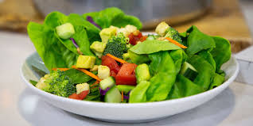 | Water | Spaguetti  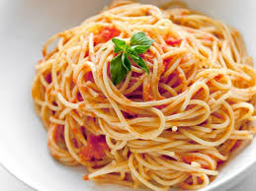 | Pumpkin soup  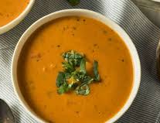
Ice cream  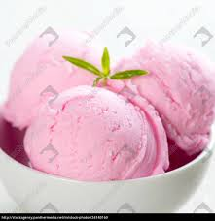 | Strawberry pie  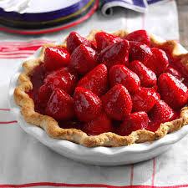 | Chicken and rice  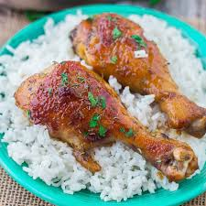 | Orange juice  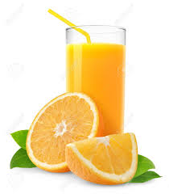
Cazuela  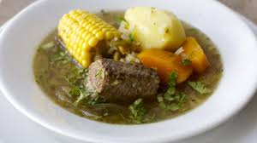 | Mozzarella sticks  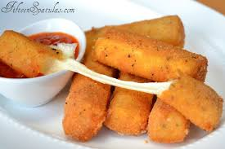 | Fruit salad  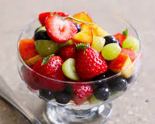 | Ice tea  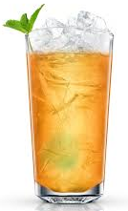

- Look at the menu and complete the dialogue

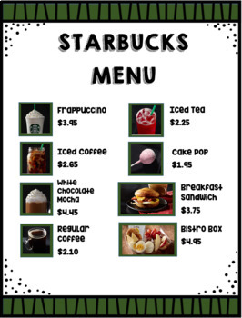
Waiter: hello! How can I help you?
Customer: Hello I’d like an iced coffe, please
Waiter: the frappuccino is $ ____________, anything else?
Customer: Yes, I want a ___________ sandwich. Is it $ _________, right?
Waiter: you’re right. It costs $3.75. Would you like a ___________? It costs only $1.95!
Customer: I’d love it!
Waiter: ok, so it’s a ______________, a ____________ and a ________________.
It´s $ _____________
Customer: here you are!
Waiter: Thanks for coming to Starbucks!

3. Put the following events in the correct order:

_______ have the main course
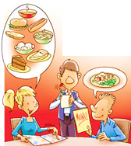
_______ ask for the bill
_______ sit down
_______ look at the menu
_______ book a table
_______ have the starter
_______ decide to go out for dinner
_______ pay the bill
_______ tip the waiter
_______ have a dessert

4. Complete the restaurant menu with words from the box.

Menu
Starters | Drinks
Main Courses | Desserts
mushroom soup mineral water
roast chicken
grilled fish
shrimp cocktail
roast beef
ice cream
coke
plum pudding
pasta
coffee
orange juice
chocolate cake

5. These are sentences commonly used in a restaurant when ordering a meal. Put the words in the correct order.

1. pay / can / with / I / a debit card?
______________________________________________________________________
2. a table / we’d / like / for two.
______________________________________________________________________
3. have / the soup of the day / first / I’ll.
______________________________________________________________________
4. the menu / have / please / we / can?
______________________________________________________________________
5. have / please / can / the bill / we ?
______________________________________________________________________
6. vegetables/ what / like / you / would?
______________________________________________________________________
7. coffee / like / some / you /would?
______________________________________________________________________
8. course / the salmon grill / for / I’d / main / like / my
______________________________________________________________________
9. to drink / what / like / you /would?
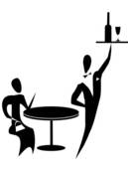
______________________________________________________________________
6. Write the sentences from activity 5 in spanish.
1) _______________________________________________________________
2) _______________________________________________________________
3) _______________________________________________________________
4) _______________________________________________________________
5) _______________________________________________________________
6) _______________________________________________________________
7) _______________________________________________________________
8) _______________________________________________________________
9) _______________________________________________________________

