NO DISPONIBLEColegio Mercedes Marín del Solar

Providencia

Prof. Areli Donoso N.

Inglés

**English Worksheet 1 “ Review ” 8th Grade**

**Name: _________________________________________ Grade__________________ Date:______________**

**Ideal Score: 21 points Score: ___________ Level of difficulty : 60% Mark: ­­­­­­­­­­­­­­­­­­­­­­­­­­­_______________**

**Objetivo: Leer, comprender e identificar información general y específica en un texto literario.**

**READING**

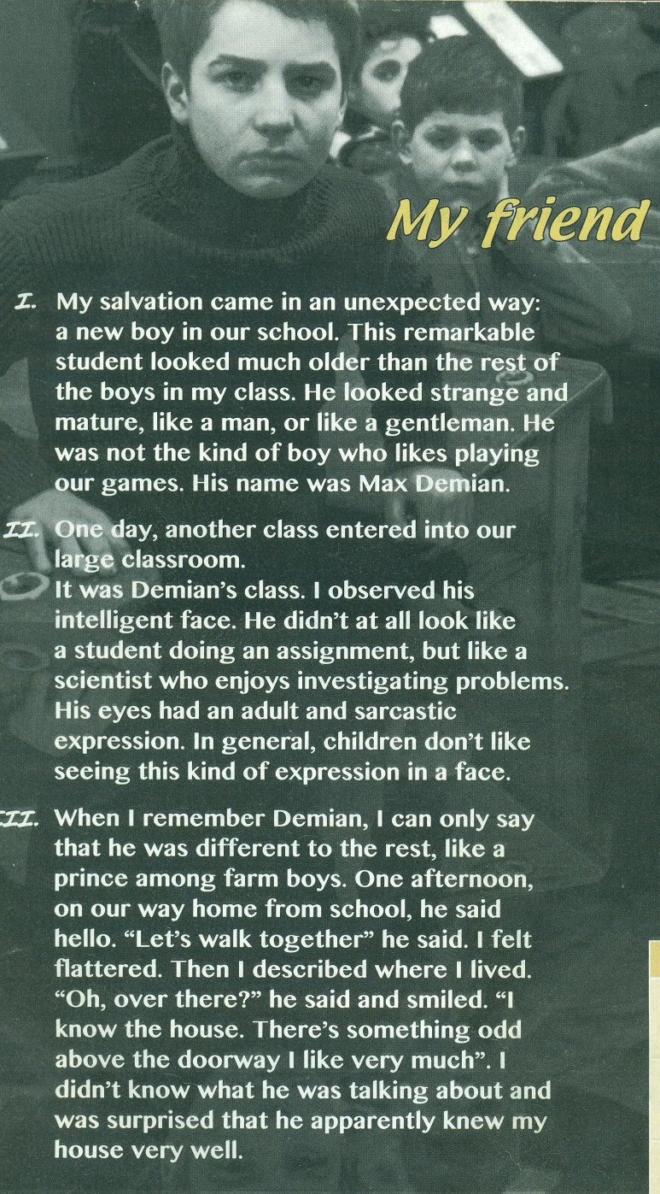

**1. Read the text about “Demian” and circle the correct alternative ( 6 points)**

**1.** The story is narrated by :

**a.** Max Demian **b.** Emile Sinclair **c**. Herman Hesse

**2.** Demian looked like :

**a.** a simple boy **b.** older than the rest **c.** a farm boy

**3.** Demian’s attitude in relation to the rest of the boys was:

**a.** mature **b.** curious **c.** ironic

**4.** the narrator and Demian were in :

**a.** the same class **b.**  adifferent class **c.** a different school.

**5.** the type of expression children don’t like to see in a face is:

**a.** an unpredictable expression **b.** an odd expression **c.** an ironic expression

**6.** When Demian said:” **Let’s walk together”**  The narrator feels:

**a.** honored **b.** happy **c.** sad

**2. Read these sentences from the text and complete them with the correct synonym. ( 5 points)**

**ironic; honored; exceptional; curious; unpredictable**

**1.**  My salvation came in an ___________________ way.

**2.** This ___________________ student looked much older.

**3.** His eyes had and adult and _______________ expression.

**4.** “Let’s walk together” he said. I felt _________________________.

**5.** There’s something ______________ above the doorway I like very much.

**Objetivo: Reconocer en un texto expresiones de preferencia**

**USE OF ENGLISH**

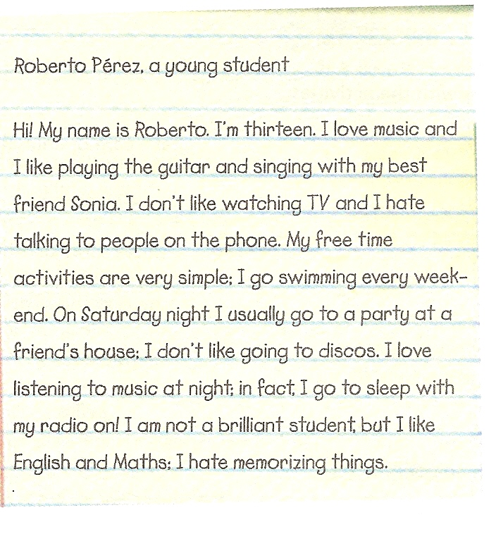

**1. In the text, ( 1 point )**

**what is Roberto doing?**

**a.** telling a story.

**b.** reporting a piece of news.

**c.** giving personal information.

**d.** inviting a friend to a party.

**2. Complete these sentences about Roberto’s likes and Dislikes. ( 6 points )**

**a.** Roberto likes _________________________________________________________

**b.** He doesn't like ________________________________________________________

**c.** At weekends he likes__________________________________________________

**d.** At night, he loves______________________________________________________

**e.** At school, he likes_________________ , but he hates ______________________

**3. Answer these questions. ( 3 points )**

**a.** How old is Roberto? _________________________________

**b.** Is he a very good student?___________________________

**c.** Who is Sonia ? _______________________________________